
International School

Capstone Project 2
CMU-SE 451

Database Design
Version 1.1
Date: 15/05/2023

TICKET BOOKING AND SCHEDULE TRACKING SYSTEM

Submitted by

Trinh, Nguyen Thi My
Huy, Nguyen Huu
Bao, Huynh Viet
Do, Nguyen Van
Viet, Tran Hung

Approved by MSC, Thuan, Nguyen Tan

Database Review Panel Representative:
Name Signature Date

Capstone Project 2 - Mentor:
Name Signature Date

PROJECT INFORMATION
Project Acronym | TSBooking
Project Title | Ticket Booking and Schedule Tracking System
Start Date | March 10, 2023 | End Date | May 25, 2023
Lead Institution | International School, Duy Tan University
Project Mentor | MSC, Thuan, Nguyen Tan  Email: thuannt.it.dtu@gmail.com  Tel: 0905626276
Scrum Master / Project Leader & contact details | Do, Nguyen Van  Email: donguyen2801@gmail.com  Tel: 0392219299
Partner Organization | Duy Tan University
Project Web URL
Team Members | Name | Email | Tel
24201208432 | Trinh, Nguyen Thi My | nguyenthimytrinh1610@gmai.com | 0378343128
2321122721 | Huy, Nguyen Huu | huynguyen291098@gmail.com | 0905067246
25211203997 | Bao, Huynh Viet | baohuynhviet145@gmail.com | 0795537477
25211603690 | Viet, Tran Hung | thviet2001@gmail.com | 0935361065

REVISION HISTORY
Version | Date | Comments | Author | Approval
1.0 | 01/04/2023 | Initial Release | C2SE.34
1.1 | 15/05/2023 | Update content | C2SE.34

DOCUMENT APPROVALS
The following signatures are required for approval of this document.
MSC, Thuan, Nguyen Tan  Mentor |  | Date
Do, Nguyen Van  Scrum master |  | Date
Trinh, Nguyen Thi My  Product Owner |  | Date
Huy, Nguyen Huu Dev Team |  | Date
Bao, Huynh Viet  Dev Team |  | Date
Viet, Tran Hung  Dev Team |  | Date

TABLE OF CONTENTS
1. Introduction 5
1.1. Purpose 5
1.2. Scope 5
1.3. Definition, Acronyms and Abbreviations 6
2. Data storage platforms 6
3. Mapping Rules 6
4. Database Design 7
4.1. Table Overview 7
4.2. Table Relationship Diagram 8
4.3. Table Details 9
4.3.1. _comment 9
4.3.2. _imageVehicles 9
4.3.3. _passengerCarCompany 9
4.3.4. _points 10
4.3.5. _pointTicket 10
4.3.6. _rate 10
4.3.7. _seats 10
4.3.8. _stations 11
4.3.9. _seatticket 11
4.3.10. _tickets 11
4.3.11. _timepoint 12
4.3.12. _trippassenger 12
4.3.13. _trips 12
4.3.14. _users 13
4.3.15. _vehicles 13

- Introduction
  - Purpose
TSBooking database design document describes structure of database and file structure of system. Database design document will introduce all attribute the application that will help developer and tester base on this design to implement and test.
  - Scope
- This Database Design Document provides the for TSBooking basic database design
- It describes both logical and physical definition, non-functional, database interfaces, tables, code create table.
- It includes the tables and performance considerations and requirements. The following topics are covered in this document:
- Assumptions and decisions on database design
- Entity – mapping
- Table, column definitions
- Constraint: primary key, unique, foreign key.
- Rule for populating specific columns
- Column and row level validation rules (check constraints)
- Interfaces and dependencies with other components.
- Data access description

- This Database Design Document TSBooking is composed of definitions for database objects derived by mapping entities to tables, attributes to columns, unique identifiers to unique keys and relationship to foreign keys.
- During design, these initial definitions are enhanced to support the functionality described in the functional specification / user stories and defined in the primary and supporting modules of the application high level design.

  - Definition, Acronyms and Abbreviations

Abbreviations | Description | Comment
PK/FK | Primary/ Foreign Key | Use to indicate a file is a Primary or Foreign key in a table
ERD | Entity Relationship Diagram | Show the relationship between entities in the system

- Data storage platforms
  - Data of application is stored in MySQL database
  - In MySQL, data structure is stored as tables that the database objects that behave as containers for the data, in which the data will be logically organized in rows and columns format.

- Mapping Rules
When mapping entities to tables, the following rules were applied:
- Entities are mapped into tables in a one to one manner.
- Attributes are mapped to columns in a one to one manner.
- One-to-many relationships are mapped to foreign keys.
- With link 1-1: set the primary key one of two relations into relations other makes foreign key.
- With link 1-n: set the primary key the one relation into many relations makes foreign key.
- With link n-n: create sub table, then set the primary key of 2 tables to make the foreign key of the sub table.

- Database Design

4.1. Table Overview
No | Table name | Short Description
01 | _comment | This table shows all the comment information
02 | _imageVehicles | This table shows all the images of the bus
03 | _passengerCarCompany | This table shows all the bus company information
04 | _points | This table shows all destinations
05 | _pointTicket | This table shows all the destinations of the ticket
06 | _rate | This table shows all reviews
07 | _seats | This table shows all seat information
08 | _seatTicket | This table shows all seats
09 | _stations | This table shows all bus station information
10 | _tickets | This table shows all bus ticket information
11 | _timePoint | This table shows all trip times
12 | _tripPassenger | This table shows all the time information of the trip
13 | _trips | This table shows all the point information of the ticket
14 | _users | This table shows all the information of the user
15 | _vehicles | This table shows all information of the bus

  - Table Relationship Diagram
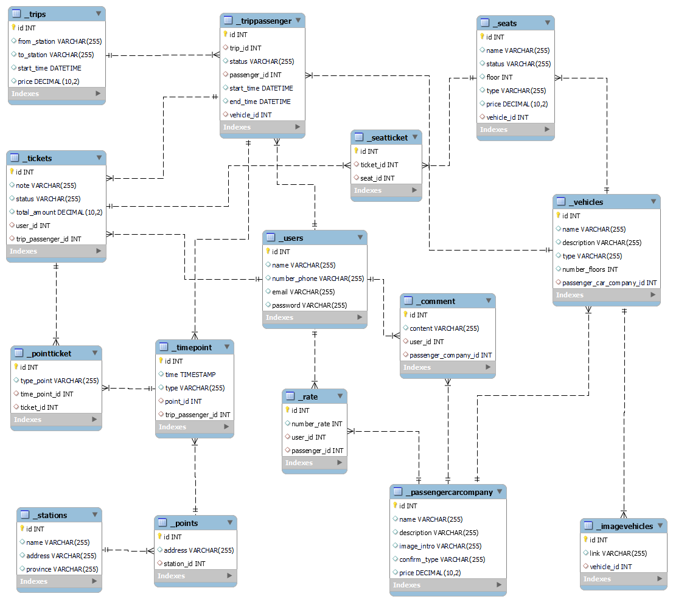

  - Table Details
    - _comment
Field Name | Data Type | Null | Key | Default | Extra
id | int | not | PK
content | varchar
user_id | Int |  | FK
passenger_company_id | int |  | FK

    - _imageVehicles
Field Name | Data Type | Null | Key | Default | Extra
id | int | not | PK
link | varchar
vehicle_id | int |  | FK

    - _passengerCarCompany
Field Name | Data Type | Null | Key | Default | Extra
id | int | not | PK
name | varchar
description | varchar
image_intro | varchar
confirm_type | varchar
price | decimal

    - _points
Field Name | Data Type | Null | Key | Default | Extra
id | int | not | PK
address | varchar
station_id | int |  | FK

    - _pointTicket
Field Name | Data Type | Null | Key | Default | Extra
id | int | not | PK
type_point | varchar
time_point_id | int |  | FK
ticket_id | int |  | FK

    - _rate
Field Name | Data Type | Null | Key | Default | Extra
id | int | not | PK
number_rate | int
user_id | int |  | FK
passenger_id | int |  | FK

    - _seats
Field Name | Data Type | Null | Key | Default | Extra
id | varchar | not | PK
name | varchar |  | FK
status | varchar
floor | int
type | varchar
price | decimal
vehicle_id | int |  | FK

    - _stations
Field Name | Data Type | Null | Key | Default | Extra
id | int | not | PK
name | varchar
address | varchar |  | PK
province | varchar

    - _seatticket
Field Name | Data Type | Null | Key | Default | Extra
id | int | not | PK
ticket_id | int |  | FK
seat_id | int |  | FK

    - _tickets
Field Name | Data Type | Null | Key | Default | Extra
id | int | not | PK
note | varchar
status | varchar
total_amount | decimal
user_id | int |  | FK
trip_passenger_id | int |  | FK

    - _timepoint
Field Name | Data Type | Null | Key | Default | Extra
id | int | not | PK
time | timestamp
type | varchar
point_id | int |  | FK
trip_passenger_id | int |  | FK

    - _trippassenger
Field Name | Data Type | Null | Key | Default | Extra
id | int | not | PK
trip_id | int |  | FK
status | varchar
passenger_id | int |  | FK
start_time | datetime
end_time | datetime
vehicle_id | int |  | FK

    - _trips
Field Name | Data Type | Null | Key | Default | Extra
id | varchar | not | PK
from_station | varchar |  | FK
to_station | varchar |  | FK
start_time | datetime
price | decimal

    - _users
Field Name | Data Type | Null | Key | Default | Extra
id | int | not | PK
name | varchar
number_phone | varchar
email | varchar
password | varchar

    - _vehicles
Field Name | Data Type | Null | Key | Default | Extra
id | int |  | PK
name | varchar
description | varchar
type | varchar
number_floors | int
passenger_car_company_id | int |  | FK

